Central Water Commission
Daily Flood Situation Report cum Advisories
10-08-2018
- Rainfall Situation

Chief Amount of rainfall recorded at 0830 hours IST of today (3 cm or more) as per IMD
Name of Place (State) | Rainfall (in cm)
Peerumedu (Kerala) | 16
Idukki (Kerala) | 13
Agumbe (Karnataka) | 11
Nilambur (Kerala), Kollur (Karnataka) | 9
Long Islands (Andaman & Nicobar Islands) | 8
Jodhpur (Rajasthan), Aryankavu , Piravom , Mananthavady (Kerala) , Subrahmanya, Gersoppa, Madikeri (Karnataka) | 7 each
Dharamsala (HP), Palakkad, Thodupuzha (Kerala) , Karkala (Karnataka) | 6 each
Hosangabad (MP), Punalur, Konni, Mavelikkara, Munnar, Myladumpara, Mannarkad, Angadippuram, Perinthalmanna (Kerala), Belthangadi, Talaguppa, Sringeri, Kammaradi (Karnataka) | 5 each
Phalodi (Rajasthan), Deomali (Odisha), Seoni & Malanjkhand (MP), Shencottah (TN), Thiruvananthapuram  City, Varkala, Kollam, Kurudamannil, Chittur & Kollengode (Kerala), Dharmasthala, Bhagamandala  (Karnataka) | 4 each
Katra (J&K), Tadong (Sikkim), Silchar (Assam), Diamond Harbour (WB), Hyderabad (Telangana), Bapatla (Andhra Pradesh), Kottayam (kerala), Mayabandar (A&N Islands), Chengalpattu, Chinnakalar, Periyar(TN), Portblair (Andaman & Nicobar Islands) Nedumangad, Kottayam, Kozha, Kumarakom & Vaikom, Chengannur, Cherthala, Kayamkulam, Kayamkulam, Alathur, Manjeri, Vadakara, Irikkur (Kerala), Kadra, Castle Rock (Karnataka) | 3 each

  - Rainfall forecast for next 5 days issued on 10th August 2018 (Midday) by IMD

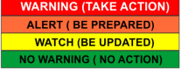
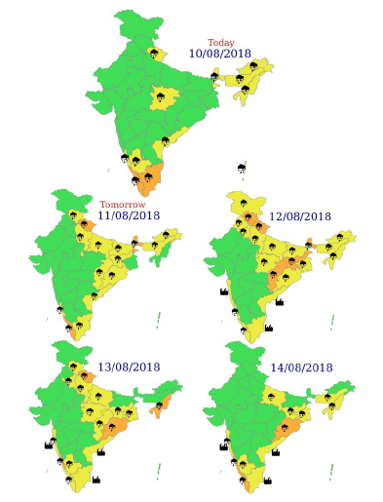

- Flood Situation on 10th August 2018

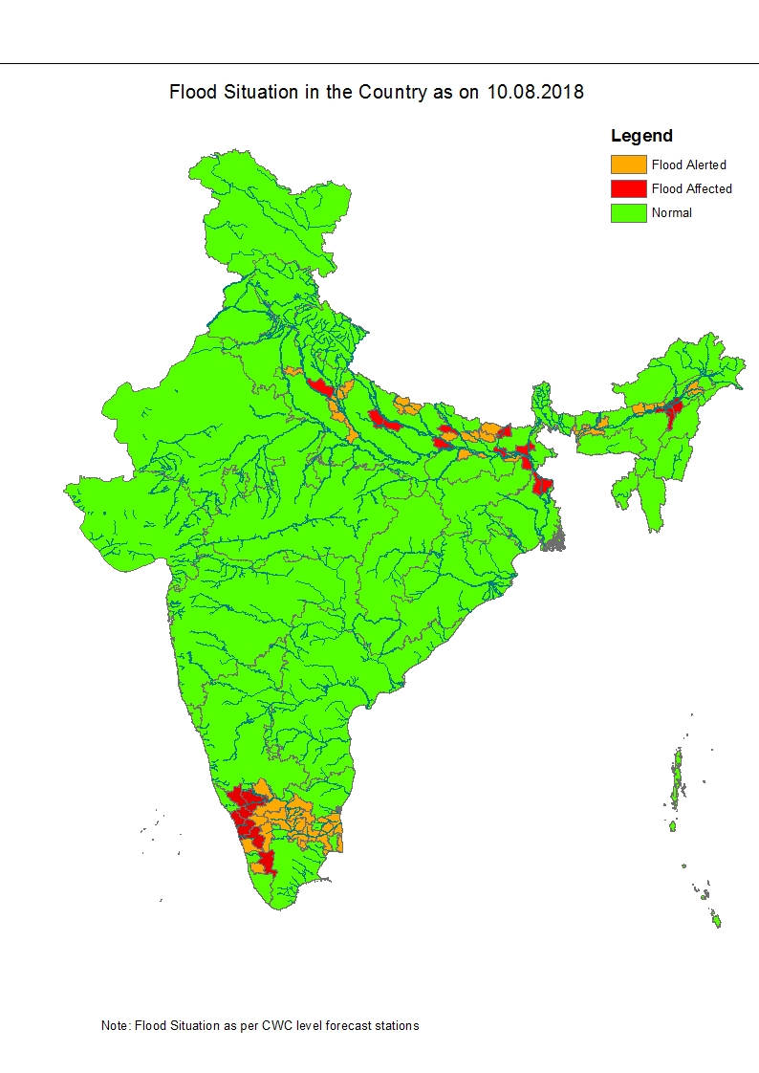
2.1 Summary of Flood Situation as per CWC Flood Forecasting network

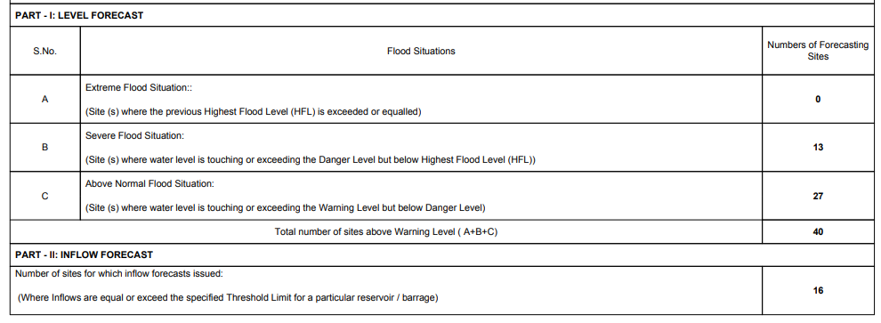

2.1.2 Severe Flood Situation

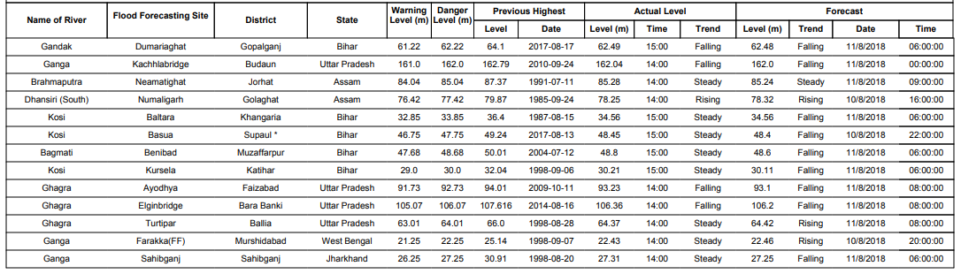

2.1.2 Above Normal
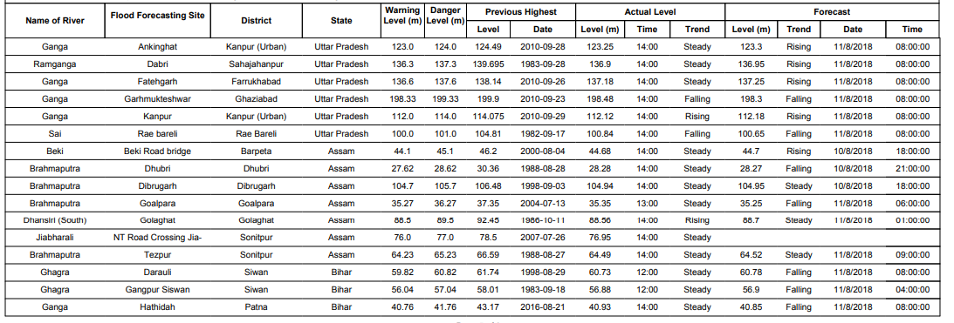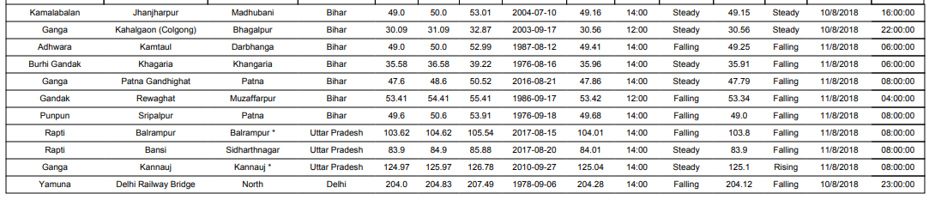
2.1.3 Reservoir
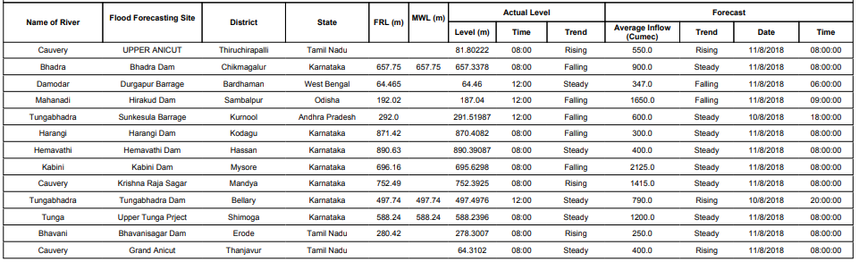
2.2 Flood Situation as per actual/forecasted rainfall situation
2.2.1 Kerala & Ghat areas of Karnataka and Tamilnadu
In view of very heavy to exceptionally heavy rainfall which occurred in Kerala on 9th August and the continuing rainfall on 10th August in Kerala, Coastal and Ghat areas of South Interior Karnataka & Tamilnadu, river Kabini at Muthankera in Wynad Dist., continued in Extreme Flood Situation but is slowly falling as shown in Hydrographs below:
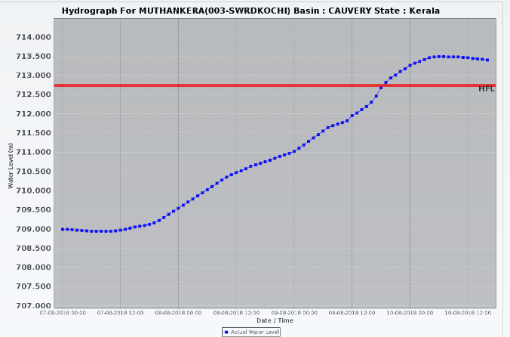
2.2.1.1 Districts Affected: Kannur, Kozhikode, Malapuram, Wynad, Palakkad (Kerala), Kodagu, Mysuru (Karnataka), Coimbatore (TN)
2.2.1.2 Districts to be alerted: Ernakulam, Kottayam, Idukki (Kerala), Mandya, Chamrajanagar, Chickmagalur, Shivamogga, Davangere (Karnataka), Dharmapuri, Krishnagiri, Salem, Namakkal, Erode, Karur, Tiruchirapalli, Thanjavur, Nagapattinam, Tiruvarur (Tamilnadu) & Karaikal (UT of Puducherry)
2.2.2 Eastern UP
Rivers Ganga, Rapti and Ghaghra are continuing to flow in Severe Flood Situation. However as the rainfall is likely to reduce in UP the rivers are likely to fall slowly from tomorrow onwards. There is likelihood of heavy to very heavy rainfall on 11th and 12th August in these basins again which may cause rise in the water levels in these rivers from 12th August 2018 onwards.
2.2.2.1 Districts affected: Barabanki, Faizabad, Balrampur, Ballia, Badaun and Rae-Bareli
2.2.3 Uttarakhand, HP, Western UP, Haryana, Chandigarh & Delhi
In view of the heavy rainfall which occurred in Uttarakhand & HP during the past 3 days, river Yamuna is flowing in Above Normal Flood Situation in Delhi Railway Bridge (North Dist., NCR, Delhi) and is likely to fall further. Again in view of heavy to very heavy rainfall forecast in Uttarakhand from 11th to 13th August 2018, there is likelihood of river levels rising in these rivers again from 12th August 2018 onwards.

