Central Water Commission
Daily Flood Situation Report cum Advisories
25-08-2018
- Rainfall Situation

Chief Amount of rainfall recorded at 0830 hours IST of today (5 cm or more) as per IMD
Name of Place (State) | Rainfall (in cm)
Barielly (UP) | 21
Moradabad (UP) | 13
Dibrugarh (Assam) | 10
Hirakud (Odisha) | 9
Gangtok (Sikkim) and Sambalpur (Odisha) | 8 each
Nahan (HP) & Najibabad (UP) | 7 each
Hardoi, Lucknow, Kanpur & Gorakhpur (UP), Daltonganj (Jharkhand) | 6 each
Dharamshala (HP), Dehradun & Pantnagar (Uttarakhand), Bahraich (UP), Midnapore (WB) and Puri (Odisha) | 5 each

  - Rainfall forecast for next 5 days issued on 25th August 2018 (Midday) by IMD

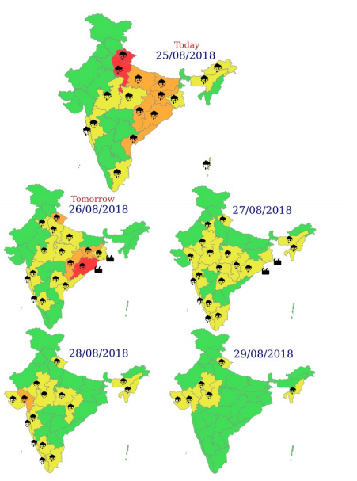
- Flood Situation on 25th August 2018

Extreme Flood Situation - Water Level above Highest Flood Level (HFL)
Severe Flood Situation - Water Level between HFL & Danger Level (DL)
Above Normal Flood Situation - Water Level between DL & Warning Level (WL)
Normal Situation - Water Level Below Warning Level
Inflow above Threshold Limit for Reservoir
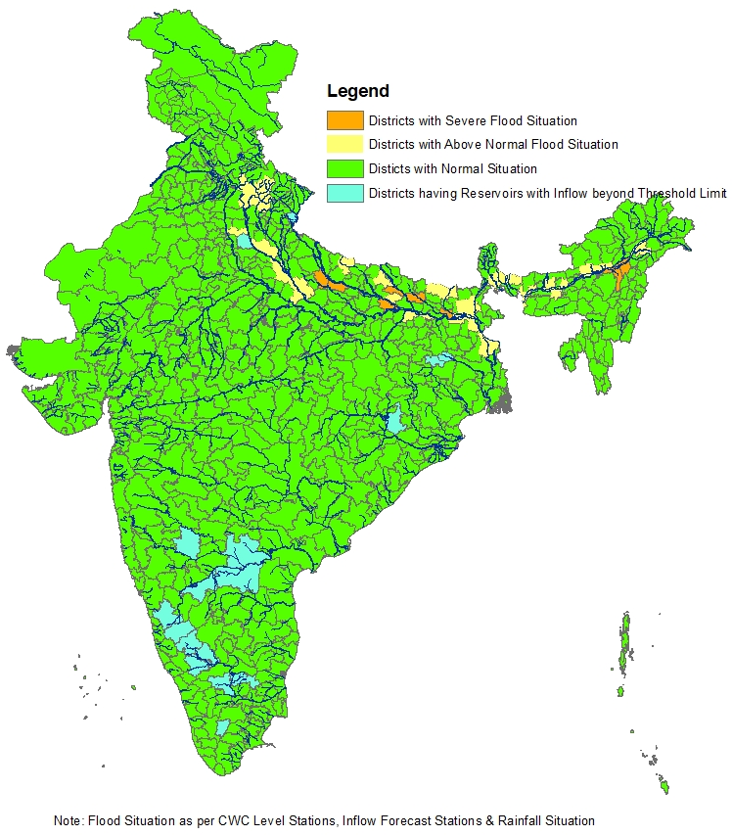
  - Summary of Flood Situation as per CWC Flood Forecasting network

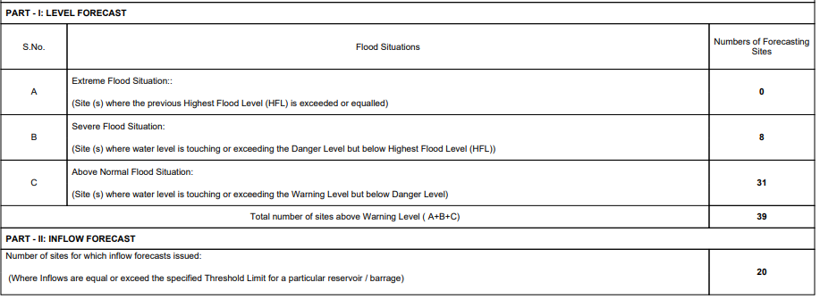
    - Severe Flood Situation

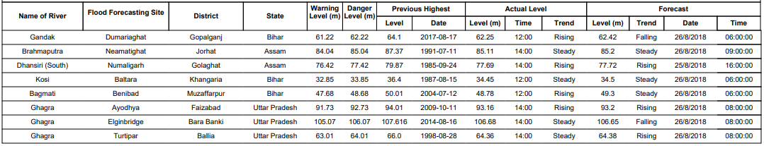
    - Above Normal

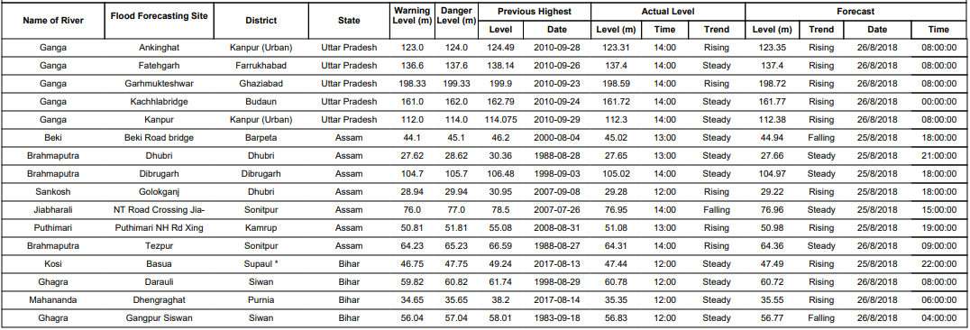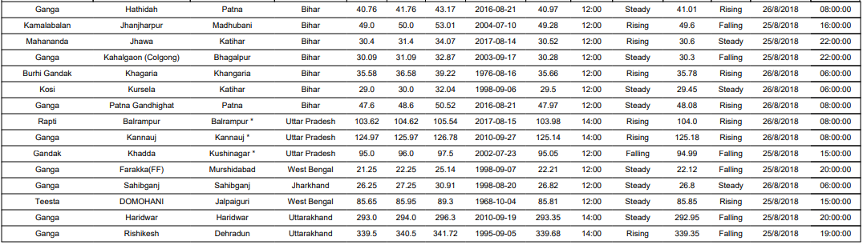

    - Reservoir

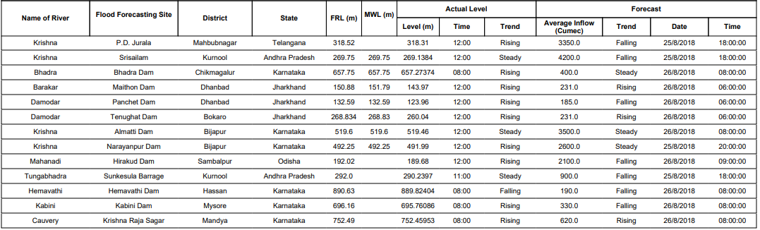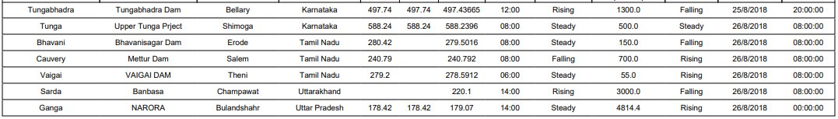
2.2 Flood Situation & Advisories as per Actual/ Forecasted Rainfall
2.2.1 Uttarakhand and UP
There is likelihood of heavy to very heavy rain with isolated Extremely heavy rain in Uttarakhand and heavy to very heavy rain in UP during the next 24 hours and heavy to very heavy rainfall in Uttarakhand and UP in the subsequent 24 hours. The situation may lead to rise in water levels in rivers Alaknanda, Bhagirathi, Yamuna, Sharda, Sarju, Ramganga, Ghaghra, Rapti and Ganga. Situation is to be monitored closely in Uttarakhand and UP. River Ganga is flowing in Above Normal Flood Situation in Haridwar and Dehradun Dist. of Uttarakhand and in Farukkahabad, Budaun, Ghaziabad, Kannauj and Kanpur Dist. of UP. River Ghaghra is flowing in Severe Flood Situation in Barabanki, Faizabad and Ballia Dist. of UP. River Rapti is flowing in Above Normal Flood Situation in Balrampur Dist. of UP. There is likelihood of heavy inflow of the order of 3000 and 4500 cumec (cubic metre per second) (1.05 lakh to 1.5 lakh cusec) in Banbasa Barrage (Uttarakhand) and Narora Barrage (UP) respectively. These situations are expected to continue for the next two days.
2.2.1.1 Districts affected
Haridwar, Dehradun, Tehri and Pauri Garhwal, Farukkahabad, Budaun, Ghaziabad, Kannauj, Kanpur, Barabanki, Faizabad, Ballia and Balrampur Dist.
2.2.1.2 Districts to be alerted
Rudraprayag, Uttarkashi, Pithoragarh and Champavat (Uttarakand), Bulandshahar, Bijnor, Moradabad, Bareilly (UP)
2.2.2 Odisha, Gangetic West Bengal, Bihar, Jharkhand, Chhattisgarh and Andhra Pradesh
Due to formation of low pressure area in Northwest Bay of Bengal and adjoining Coastal West Bengal and North Odisha, there is likelihood of heavy to very heavy rainfall at isolated places in Jharkhand, Bihar, Odisha and Andhra Pradesh on 26th August. Heavy to very heavy rainfall with isolated extremely heavy rainfall in Odisha and heavy to very heavy rainfall in Chhattisgarh, Jharkhand have been forecasted on 27th August and heavy rainfall at isolated places in Odisha, Chhattisgarh have been forecasted on 28th August.
This spell of rain in the next 3 days is likely to increase the Water Levels on rivers such as Damodar, Subarnarekha, Burhabalang, Brahmani and Baitarni, Mahanadi, Rishikulya, Vamsadhara, Nagavali, Indravathi and Sabari river basins. There is also likelihood of rise in inflows into reservoirs in Damodar, Subarnarekha, Brahmani & Baitarni, Mahanadi, Vamsadhara, Indravathi and Kolab Basins in these States. Necessary precautionary steps have to be taken while releasing any excess water taking into consideration the downstream flood condition as well as the expected rough to very rough seas in North Bay of Bengal.
2.2.3 Karnataka, Kerala and Tamilnadu
IMD has forecasted increase in rainfall with isolated heavy rainfall on 26th, 28th and 29th August in Tamilnadu, on 27th, 28th and 29th August in Karnataka, 28th and 29th August in Kerala. Since many of the dams in these States in basins of Cauvery and its tributaries, Vaigai, Periyar and other West Flowing river between Tadri and Kanyakumari are already very near Full Reservoir Levels, necessary precautions have to be taken while releasing excess flow taking into account the downstream flood situation and the standard operating procedures and rule curves.

