

Central Water Commission
Daily Flood Situation Report cum Advisories
19-08-2018
- Rainfall Situation

Chief Amount of rainfall recorded at 0830 hours IST of today (3 cm or more) as per IMD
Name of Place (State) | Rainfall (in cm)
Mahabubabad (Telangana) | 15
Garla (Telangana), Agumbe (Karnataka) | 13 each
Bayyaram and Dornakal (Telangana) | 12 each
Kollur (Karnataka) | 10
Dharamshala (HP), Kandla (Gujarat), Mahabaleshwar (Maharashtra), Munnar (Kerala), Bhagamandala & Madikeri (Karnataka) | 9 each
Hirakud (Odisha), Karkala & Koppa (Karnataka) | 8 each
Nandigama (Andhra Pradesh), Sambalpur (Odisha), Yellandu, Khammam, Mulakalpalle, Narasampet, Nallabelle (Telangana), Sringeri (Karnataka), Chinnakalar (TN) | 7 each
Vijayawad (Andhra Pradesh), Madhira (Telangana), Mudubidre (Karnataka) | 6 each
Kota (Rajasthan), Rewa (MP), Honavar (Karnataka), Long Islands & Port Blair (A&N), Valparai (TN) | 5 each
Churu (Rajasthan), Machilipatinam (Andhra Pradesh), Matheran (Maharashtra), Malanjkhand (MP), Devala (TN), Perumbavur (Kerala) | 4 each
Ambala (Haryana), Mangalore (Karnataka) and Narsapur (Andhra Pradesh) | 3 each

  - Rainfall forecast for next 5 days issued on 19th August 2018 (Midday) by IMD


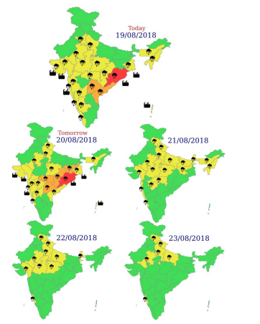
- Flood Situation on 19thAugust 2018

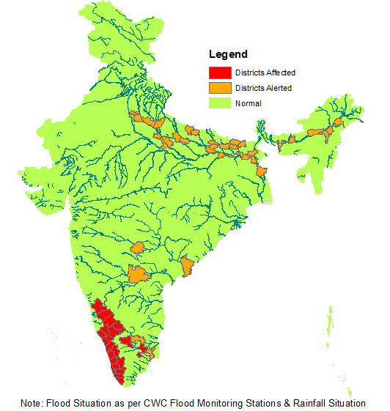

2.1 Summary of Flood Situation as per CWC Flood Forecasting network
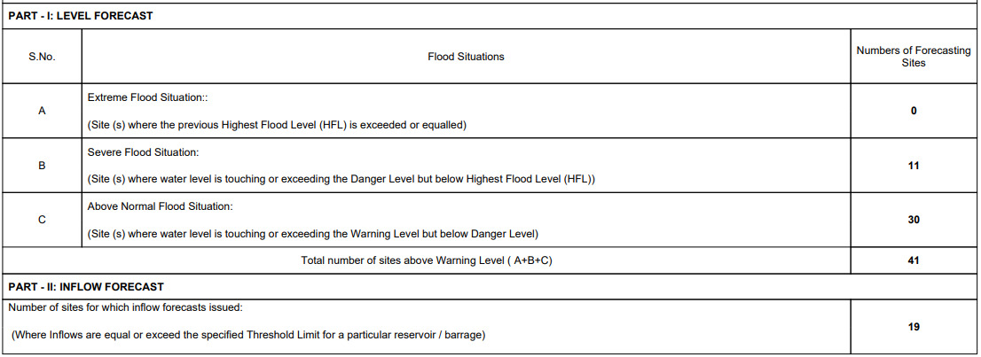
    - Severe Flood Situation

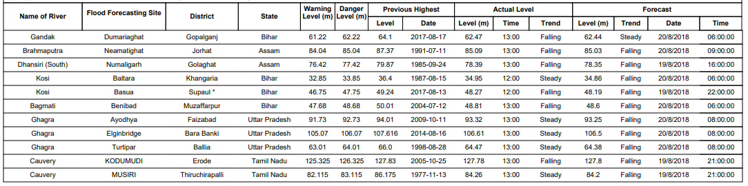
    - Above Normal

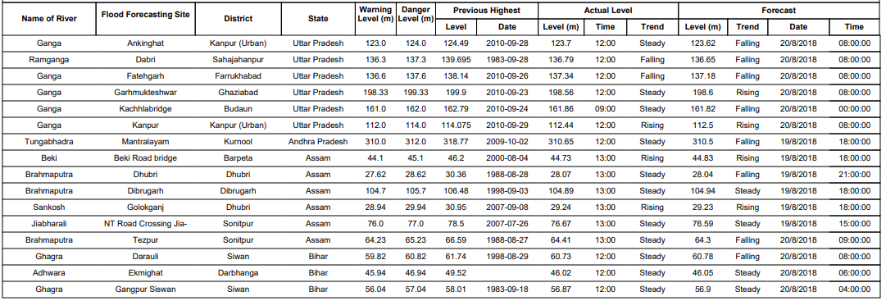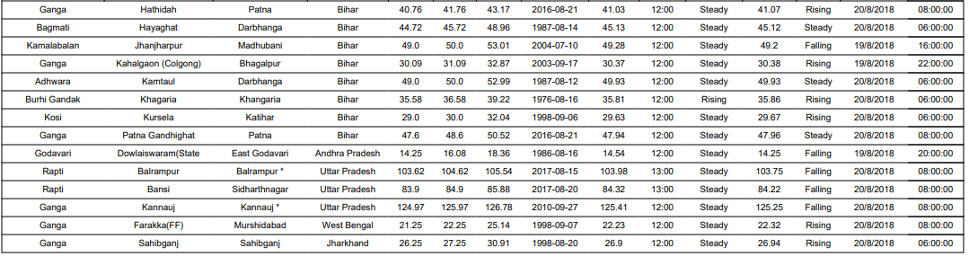

2.1.3 Reservoir
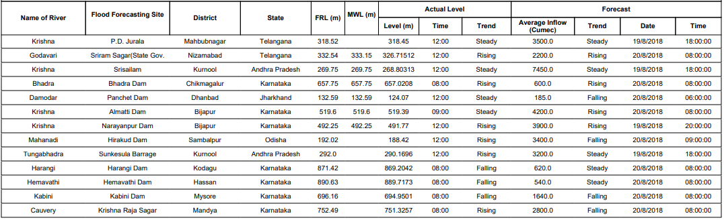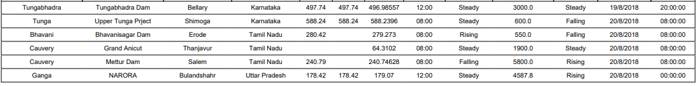
2.2 Flood Situation & Advisories as per Actual/ Forecasted Rainfall
2.2.1 Kerala & Ghat areas of Karnataka and Tamilnadu
Heavy rain is forecasted for 20th August only for this region. The flood situation is likely to recede to normal slowly in all the affected areas during the next 5 days as there will be significant reduction in rainfall.
River Cauvery is still flowing in Extreme Flood Situation in upstream of Krishnarajasagar reach in Karnataka and in Severe Flood Situation in Tamilnadu. There is a general falling trend in rivers in Kerala, Karnataka and Tamilnadu as the rainfall intensity is reducing.
2.2.1.1 Districts Affected: Kannur, Kozhikode, Malapuram, Wynad, Palakkad, Thrissur, Ernakulam, Kottayam, Idukki, Pattanamthitta, Alappuzha, Thiruvananthapuram, Kollam (Kerala), Kodagu, Mysuru, Mandya, Chamarajanagar, Chickmagalur, Shivamogga (Karnataka), Erode, Karur, Tiruchirapalli, Thanjavur (Tamilnadu)
2.2.2 Andhra Pradesh, Odisha, Chhattisgarh, Telangana and Maharashtra
Due to very heavy rainfall which occurred in Lower Krishna Basin Catchment, there is likelihood of rise in inflows into Dr K L R S Pulichintala Project in Guntur District and Prakasam Barrage in Krishna District of Andhra Pradesh. In association with the low pressure area in North West Bay of Bengal off Odisha Coast, there is likelihood of heavy to very heavy rainfall with isolated extremely heavy rainfall in Odisha on 20th and 21st August. Heavy to very heavy rainfall at isolated places is also predicted for Chhattisgarh, Andhra Pradesh, Telangana and Vidarbha for 20th and 21st August. This may give rise to rapid rise in levels in Brahmani & Baitarni, Mahanadi, Rishikulya, Vamsadhara, Nagavali and Godavari Basin downstream of Sriramsagar Project including Pranhita, Indravathi and Sabari Basins. Watch has to be maintained for above normal to severe floods in these basins during the next 72 hours.
2.2.6 Odisha, Chhattisgarh, Gangetic West Bengal and Jharkhand
Due to likely formation of low pressure area in Bay of Bengal, there is chance of enhancement in rainfall in these states from 19th August 2018 onwards. Dams in Damodar and Subarnarekha Basins are likely to witness increase in inflows during the next two days. Situation has to be monitored closely for heavy to very heavy rainfall in these areas.

