Central Water Commission
Daily Flood Situation Report cum Advisories
17-08-2018
- Rainfall Situation

Chief Amount of rainfall recorded at 0830 hours IST of today (8 cm or more) as per IMD
Name of Place (State) | Rainfall (in cm)
Chinna Kallar (TN) | 26
Castle Rock (Karnataka) | 22
Valparai (TN), Bhagamandala (Karnataka) | 21 each
Peermad (Kerala) | 19
Khandwa (MP) | 17
Aurangabad & Mahabaleshwar (Maharashtra), Virajpet (Karnataka) | 16 each
Vellannikkara & Irinjalakuda (Kerala) | 15 each
Khargone (MP) | 14
Agumbe (Karnataka), Jalgaon & Buldana (Maharashtra), Munnar (Kerala) | 13
Alathur (Kerala) | 12
Washim (Maharashtra), Konni (Kerala), Devala (TN) | 11 each
Punalur, Palakkad, Pattambi, Perumbavur, Kunnamkulam, Mananthavady & Vythri (Kerala), Nanded (Maharashtra), Adilabad (Telangana) | 10 each
Kottayam (Kerala), Vallabh Vidyanagar (Gujarat), Matheran (Maharashtra) | 9 each
Vadodara (Gujarat), Parbhani & Akola (Maharashtra), | 8 each

  - Rainfall forecast for next 5 days issued on 17th August 2018 (Midday) by IMD

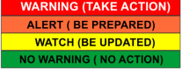
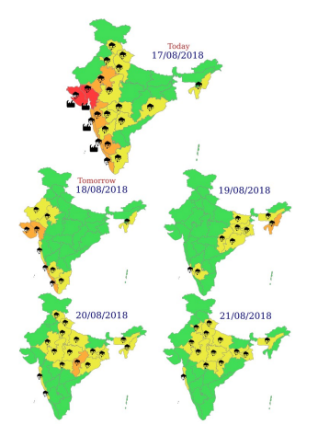
- Flood Situation on 17thAugust 2018
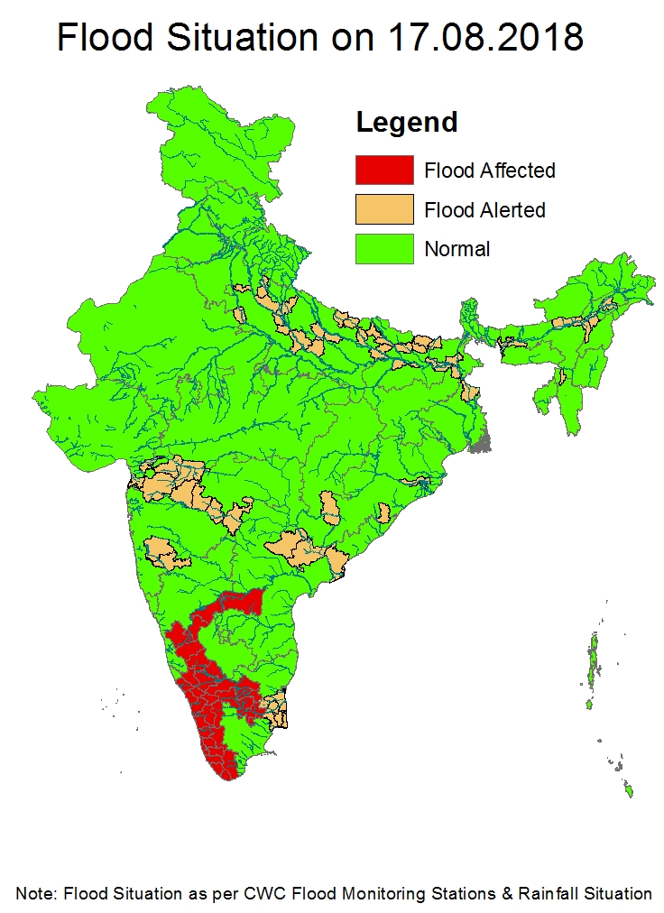

2.1 Summary of Flood Situation as per CWC Flood Forecasting network
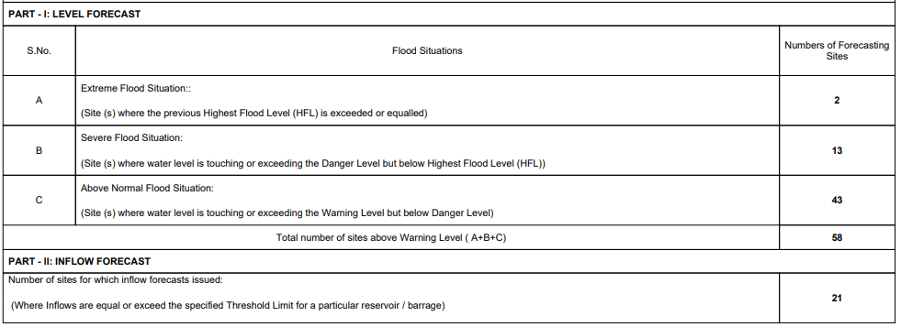
    - Extreme Flood Situation

2.1.2 Severe Flood Situation
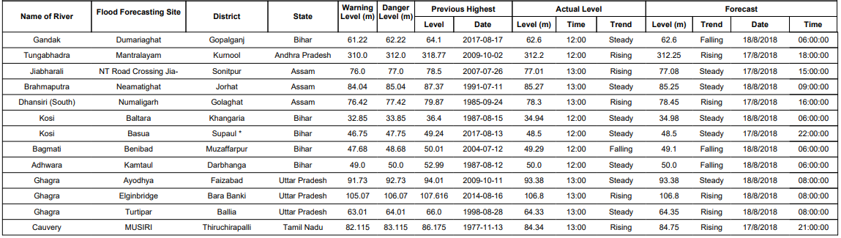
2.1.3 Above Normal
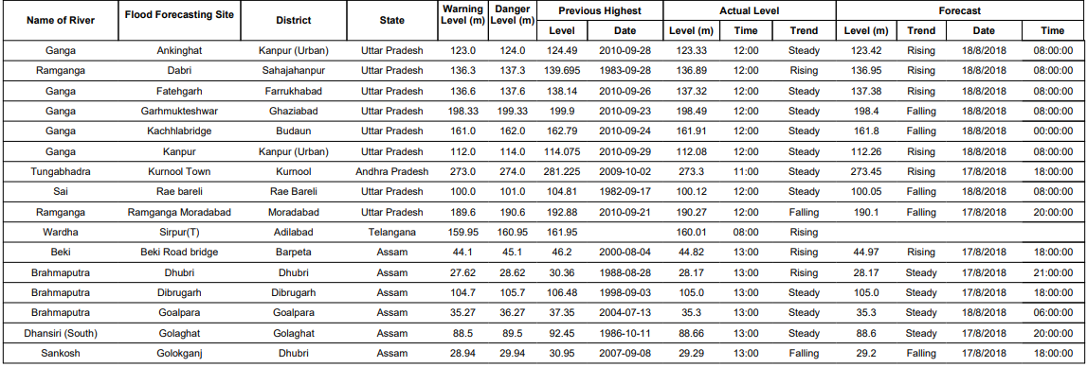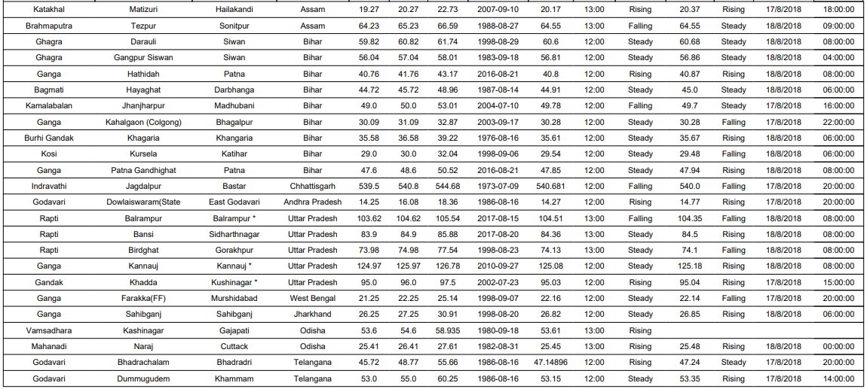

2.1.4 Reservoir
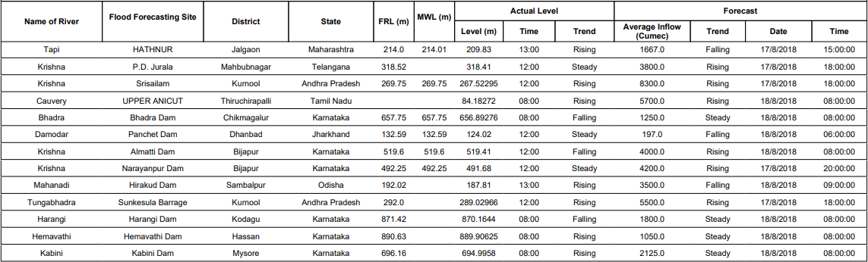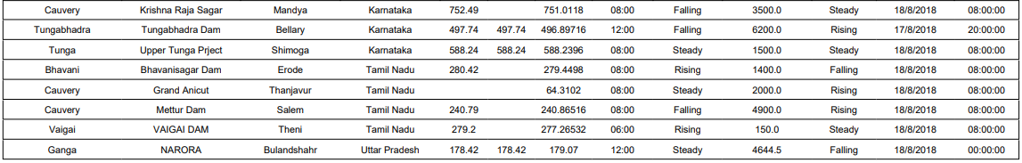
2.2 Flood Situation & Advisories as per Actual/ Forecasted Rainfall
2.2.1 Kerala & Ghat areas of Karnataka and Tamilnadu
Heavy to very heavy rainfall has been forecasted at isolated places on 18thAugust and isolated heavy rainfall on 19th August in above areas. 8 Flood Monitoring Stations in Kerala, Karnataka and Tamilnadu are flowing in Extreme Flood Situation today as given in the Table Below:
S.  No. | Name of Site | River | State | District | HFL (m) | Level/ Trend
1. | Kumbidi | Bharathapuzha | Kerala | Palakkadu | 9.76 | 11.27 S
2. | Muthankera | Kabini | Kerala | Wynad | 712.735 | 713.23 F
3. | Kalampur | Kaliyar | Kerala | Ernakulam | 14.96 | 16.49 F
4. | Kudige | Cauvery | Karnataka | Kodagu | 820.41 | 822.28 R
5. | Chunchunkatte | Cauvery | Karnataka | Mysuru | 757.35 | 759.13 R
6. | Holehonnur | Bhadra | Karnataka | Chikmagaluru | 561.04 | 561.58 R
7. | Savandapur | Bhavani | Tamilnadu | Erode | 186.88 | 187.50 F
8. | Kodumudi | Cauvery | Tamilnadu | Erode | 127.83 | 127.92 R

Levels of Sites in Kerala which flowed in Extreme Situation on 16th August 2018 but have since fallen or data is not available (DNA) due to communication failure.

S.  No. | Name of Site | River | District | HFL | Level /Trend
1. | Kumbidi | Bharathapuzha | Palakkadu | 9.76 | 11.27 S
2. | Arangali | Chalakudi | Thrissur | 7.62 | DNA
3. | Muthankera | Kabini | Wynad | 712.735 | 713.23 F
4. | Neeleswaram | Periyar | Ernakulam | 11.105 | DNA
5. | Kalampur | Kaliyar | Ernakulam | 14.96 | 16.49 F
6. | Ramamangalam | Muvattupuzha | Ernakulam | 8.42 | DNA
7. | Vandiperiyar | Periyar | Idukki | 793.8 | DNA
8. | Pulamanthole | Pulanthod | Palakkadu | 19.07 | 18.65 F
9. | Perumannu | Valapatnam | Kannur | 14.75 | 14.12 F
10. | Kuttayadi | Kuttayadi | Kozhikode | 8.32 | 6.26 F
11. | Mankara | Bharathapuzha | Palakkadu | 51.55 | 51.25 F
12. | Kidangoor | Meenachil | Kottayam | 8.01 | DNA
Trend: R-Rising, F- Falling, S-Steady, DNA- Data Not Available
2.2.1.1 Districts Affected: Kannur, Kozhikode, Malapuram, Wynad, Palakkad, Thrissur, Ernakulam, Kottayam, Idukki, Pattanamthitta, Alappuzha, Thiruvananthapuram, Kollam (Kerala), Kodagu, Mysuru, Mandya, Chamarajanagar, Chickmagalur, Shivamogga, Davangere, Ballari (Karnataka), Coimbatore, Dharmapuri, Salem, Namakkal, Erode, Karur, Tiruchirapalli, Thanjavur, Nagapattinam, Tiruvarur, Ariyalur, Perambalur (Tamilnadu) & Karaikal (UT of Puducherry)
2.2.3 Andhra Pradesh, Chhattisgarh, Telangana and Maharashtra
River Indravathi is flowing in Above Normal Flood Situation in Jagdalpur in Bastar Dist of Chhattisgarh, River Godavari is flowing in Above Normal Flood Situation at Eturunagaram in Jayashankar Bhupalapally Dist., Dummagudem and Bhadrachalam in Bhadradri Kothagudem Dist. of Telangana, Kunavaram & Dowlaiswaram Barrage in East Godavari Dist of Andhra Pradesh. River Tungabhadra at Mantralayam is in Severe Flood Situation and Kurnool in Kurnool District is in Above Normal Flood Situation. Both the stations are likely to continue flowing above normal situation during the next 24 hours and then slowly fall.
2.2.4 Gujarat
Due to likely movement of depression on 17thAugust over Gujarat and adjoining Daman & Diu, rivers Tapi, Narmada and Damanganga are rising. Hatnur Dam is getting inflows due to heavy rainfall. In view of the likely rainfall in Damanganga Basin, Madhuban Dam is also likely to get heavy inflows.
2.2.5 Eastern UP
Rivers Ganga, Rapti and Ghaghra are continuing to flow in Severe Flood Situation. However as the rainfall has reduced in UP, the rivers are likely to fall slowly from tomorrow onwards.
2.2.5.1 Districts affected: Barabanki, Faizabad, Balrampur, Ballia, Badaun and Rae-Bareli

