Central Water Commission
Daily Flood Situation Report cum Advisories
16-08-2018
- Rainfall Situation

Chief Amount of rainfall recorded at 0830 hours IST of today (8 cm or more) as per IMD
Name of Place (State) | Rainfall (in cm)
Peermade (Kerala) | 35
Valparai (TN) | 31
Ponnani (Kerala) | 27
Vadakara (Kerala), Madikeri (Karnataka) | 26 each
Vellanikkara & Enamackel (Kerala) | 25 each
Mannarkad (Kerala), Subrahmanya (Karnataka) | 24 each
Kunnamkulam & Alathur (Kerala) | 23 each
Chalakudy (Kerala) | 22
Agumbe (Karnataka) | 20
Ottappalam & Thrithala (Kerala) | 21 each
Sohra (Meghalaya), Irinjalakuda (Kerala) | 19 each
Thodupuzha, Kodungallur & Pattambi (Kerala) | 18 each
Palakkad, Kollengode & Manjeri (Kerala), Devala (TN), Castle Rock, Bhagamandala, Madapura (Karnataka) | 17 each
Perinthalmanna. Angadippuram & Quilandy (Kerala), Belthangadi (Karnataka) | 16 each
Parambikulam & Nilambur (Kerala) | 15 each
Mahabaleswar (Maharashtra), Kozha & Ernakulam South (Kerala) | 14 each
Kozhikode, Piravom (Kerala), Dharmasthala (Karnataka) | 13 each
Konni (Kerala). Periyar, Naduvattam (TN) | 12 each
Kochi Air Port, Aluva & Chittur (Kerala), Gudalur Bazar (TN), Sulya, Karkala, Napoklu, Virajpet (Karnataka) | 11 each
Alappuzha (Kerala), Mudubidre, Puttur, Kollur (Karnataka) | 10 each
Adilabad (Telangana), Bramhapuri & Chandrapur (Maharashtra) ,Jagdalpur (Chhattisgarh), Aryankavu, Haripad, Vaikom & Vythiri (Kerala), Shencottah (TN), Somawarpet (Karnataka) | 9 each
Ramgundam (Telangana), Cherthala & Kuppady (Kerala), Siddapura, Gersoppa, Linganamakki (Karnataka) | 8 each

  - Rainfall forecast for next 5 days issued on 16th August 2018 (Midday) by IMD

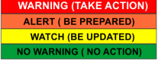
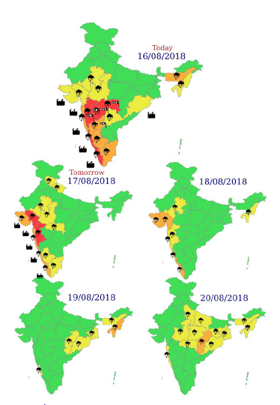
- Flood Situation on 16th August 2018
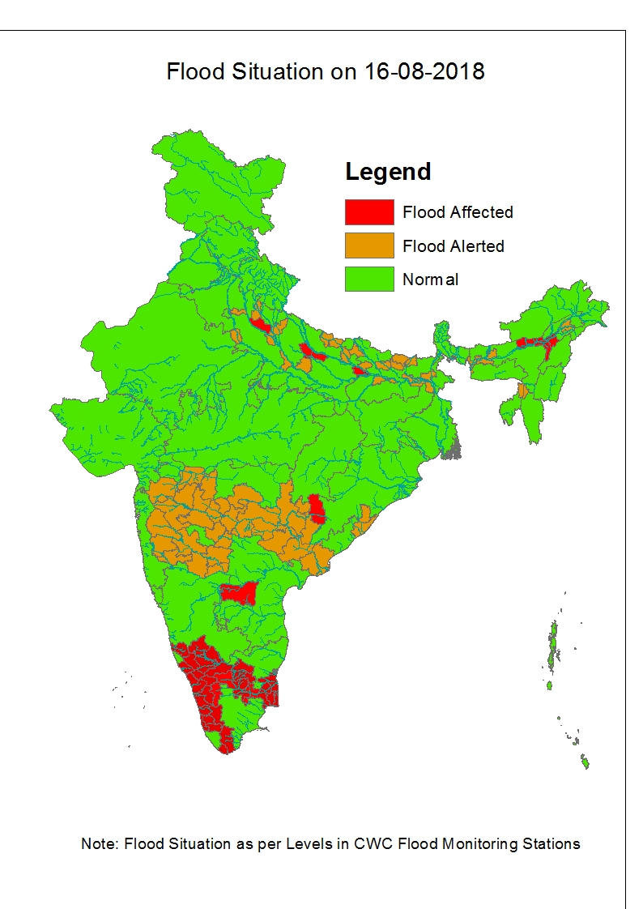

2.1 Summary of Flood Situation as per CWC Flood Forecasting network

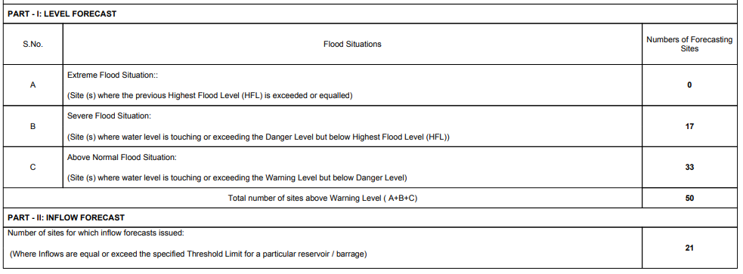

2.1.2 Severe Flood Situation

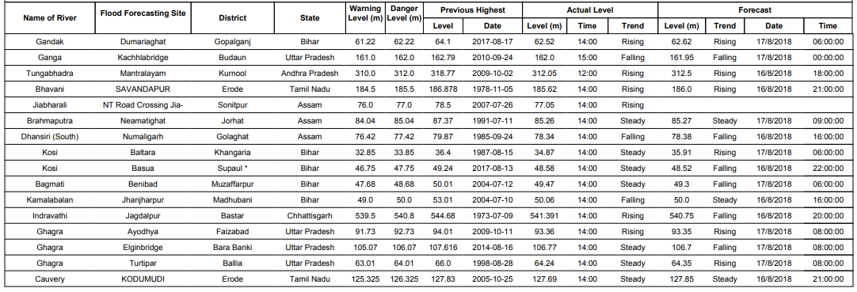
2.1.2 Above Normal
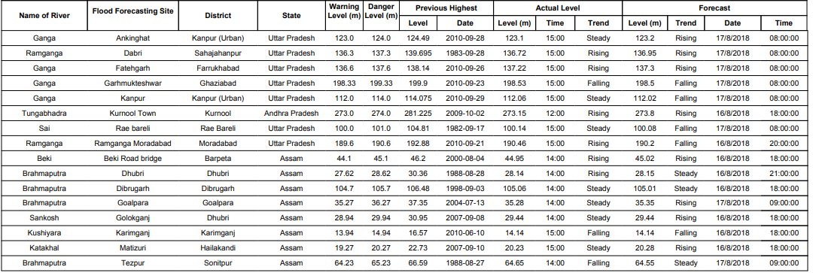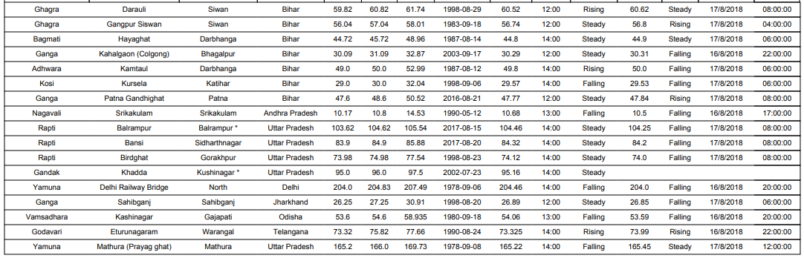
2.1.3 Reservoir
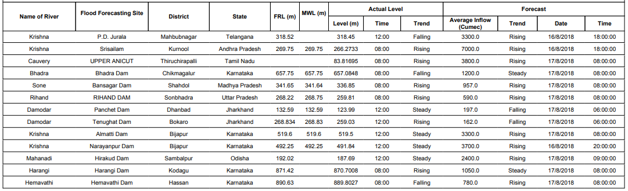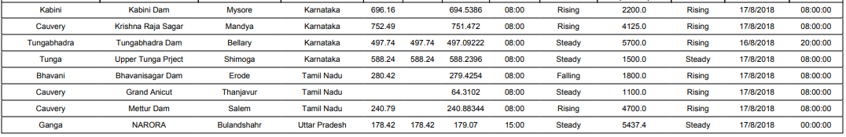
2.2.1 Kerala & Ghat areas of Karnataka and Tamilnadu
Heavy rain at a few places to very heavy rainfall at isolated places has been forecasted for 17th August. Heavy to very heavy rainfall has been forecasted at isolated places on 18th August and isolated heavy rainfall on 19th August in above areas. 16 Flood Monitoring Stations in Kerala, Karnataka and Tamilnadu are flowing in Extreme Flood Situation today as given in the Table Below:
S.No |  | Name of Site |  | River |  | State |  | District |  | HFL |  | Level /Trend  Today
1. |  | Kumbidi |  | Bharathapuzha |  | Kerala |  | Palakkad |  | 9.76 |  | 10.02 R
2. |  | Arangali |  | Chalakudi |  | Kerala |  | Thrissur |  | 7.62 |  | 9.18 R
3. |  | Muthankera |  | Kabini |  | Kerala |  | Wynad |  | 712.735 |  | 712.94 R
4. |  | Neeleswaram |  | Periyar |  | Kerala |  | Ernakulam |  | 11.105 |  | 12.1 R
5. |  | Kalampur |  | Kaliyar |  | Kerala |  | Ernakulam |  | 14.96 |  | 17.47 R
6. |  | Ramamangalam |  | Muvattupuzha |  | Kerala |  | Ernakulam |  | 8.42 |  | 9.02 R
7. |  | Vandiperiyar |  | Periyar |  | Kerala |  | Idukki |  | 793.8 |  | 797.1 F
8. |  | Pulamanthole |  | Pulanthod |  | Kerala |  | Palakkad |  | 19.07 |  | 19.13 R
9. |  | Perumannu |  | Valapatnam |  | Kerala |  | Kannur |  | 14.75 |  | 15.05 R
10. |  | Kuttayadi |  | Kuttayadi |  | Kerala |  | Kozhikode |  | 8.32 |  | 8.36 F
11. |  | Mankara |  | Bharathapuzha |  | Kerala |  | Palakkad |  | 51.55 |  | 52.4 R
12. |  | Kidangoor |  | Meenachil |  | Kerala |  | Kottayam |  | 8.01 |  | 8.10 R
 | 13. |  | Kudige |  | Cauvery |  | Karnataka |  | Kodagu |  | 820.41 |  | 821.40 R
 | 14 |  | Chunchunkatte |  | Cauvery |  | Karnataka |  | Mysuru |  | 757.35 |  | 757.85 R
 | 15. |  | Holehonnur |  | Bhadra |  | Karnataka |  | Chickmagalur |  | 561.04 |  | 561.43 F
 | 16. |  | Nellithurai |  | Bhavani |  | Tamilnadu |  | Coimbatore |  | 308.25 |  | 309.41 F

R: Rising, F: Falling.

Some of the hydrographs are shown below
Kerala
: 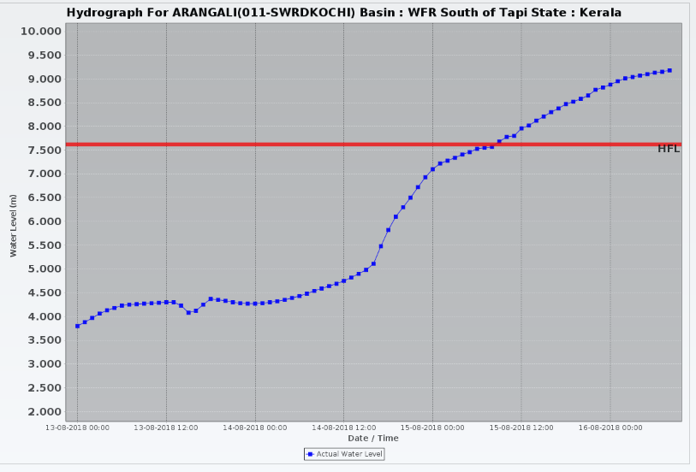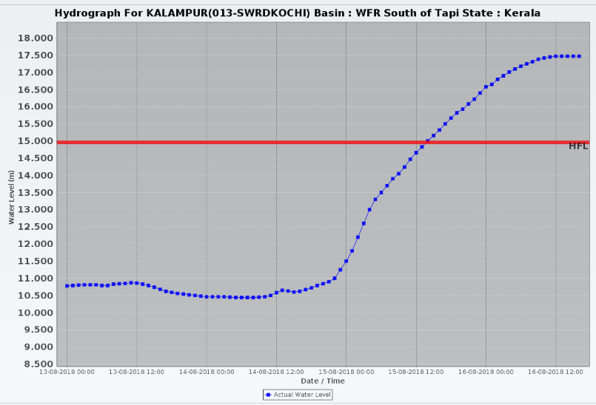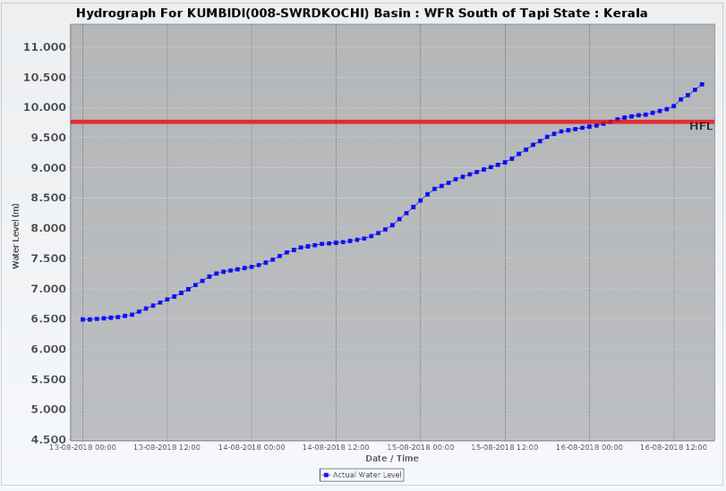
Karnataka & Tamilnadu
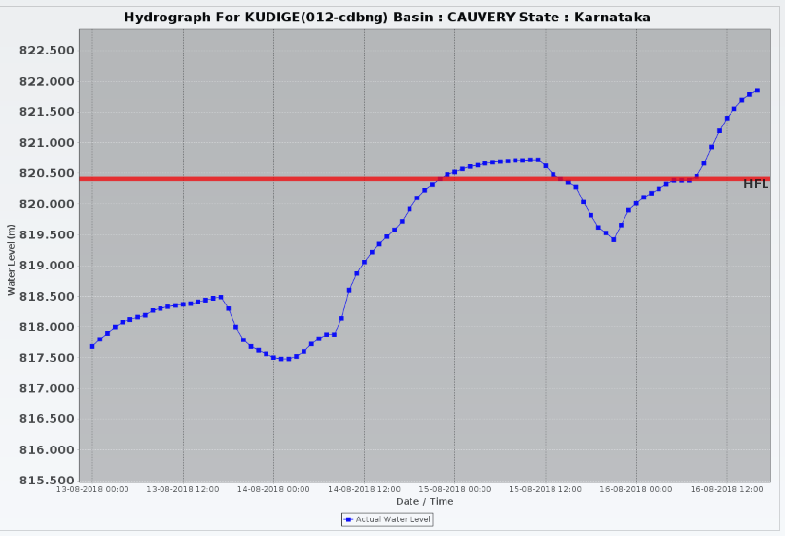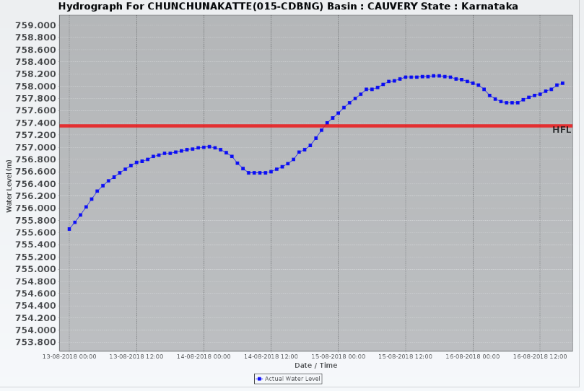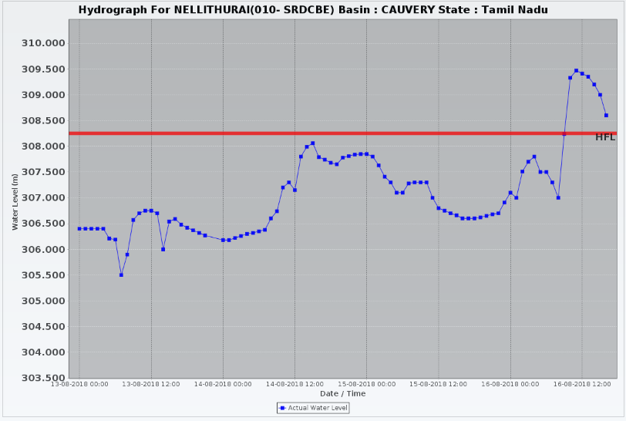
2.2.1.1 Districts Affected: Kannur, Kozhikode, Malapuram, Wynad, Palakkad, Thrissur, Ernakulam, Kottayam, Idukki, Pattanamthitta, Alappuzha, Thiruvananthapuram (Kerala), Kodagu, Mysuru, Mandya, Chamarajanagar, Chickmagalur, Shivamogga, Davangere, Ballari (Karnataka), Coimbatore, Dharmapuri, Salem, Namakkal, Erode, Karur, Tiruchirapalli, Thanjavur, Nagapattinam, Tiruvarur, Ariyalur, Perambalur (Tamilnadu) & Karaikal (UT of Puducherry)

2.2.3 Andhra Pradesh, Chhattisgarh, Telangana and Maharashtra
In view of the movement of Depression, heavy to very heavy rain with isolated extremely heavy rainfall has been forecasted for Godavari Basin, River Godavari is flowing in Above Normal Flood Situation at Eturunagaram in Jayashankar Bhupalappli Dist. of Telangana. It is also likely to rise in Bhadradri Kothagudem Dist. of Telangana and flow in Above Normal Flood Situation tomorrow. In view of the rainfall forecast for next 2 days, there is likelihood of levels continuing in Above Normal Situation. River Tungabhadra at Mantralayam is in Severe Flood Situation and Kurnool in Kurnool District is in Above Normal Flood Situation. River Nagavali at Srikakulam Dist Andhra Pradesh is in Above Normal situation but is likely to fall by tomorrow. Both the stations are likely to flow in Severe Flood Situation for another 2 days. River Indravathi at Jagdalpur in Bastar Dist Chhattisgarh is flowing in Severe Flood Situation and is likely to fall to Above Normal Flood Situation by tomorrow.
2.2.4 Gujarat
Due to likely movement of depression on 17th August over Gujarat and adjoining Daman & Diu, rivers Tapi, Narmada and Damanganga are expected to rise.
2.2.5 Eastern UP
Rivers Ganga, Rapti and Ghaghra are continuing to flow in Severe Flood Situation. However as the rainfall has reduced in UP, the rivers are likely to fall slowly from tomorrow onwards.
2.2.5.1 Districts affected: Barabanki, Faizabad, Balrampur, Ballia, Badaun and Rae-Bareli

