Central Water Commission
Daily Flood Situation Report cum Advisories
06-10-2018
- Rainfall Situation

Chief Amount of rainfall recorded at 0830 hours IST of today (4 cm or more) as per IMD
Name of Place (State) | Rainfall (in cm)
Karaikal (UT of Puducherry) | 12
Villupuram (TN) | 9
Coonoor (TN), Kollur (Karnataka) | 8 each
Mylam & Mayiladhthurai (TN) | 7 each
Mettupalayam, Panruti, Needamangalam, Kancheepuram & Vanur (TN), Gerusoppa & Linganamakki (Karnataka) | 6 each
Cuddalore, Nagapattinam, Vedaranyam, Thiruthuraipoondi,Kotagiri, Papanasam, Ketti & Penucondapuram (TN), Vellanikkara (Kerala), Bantwal & Honavar (Karnataka) | 5 each
Tirukoilur, Sirkazhi, Ulundurpettai, Gingee, Ramanathapuram, Tindivanam, Chidambaram, Uthagamandalam, Nannilam, Tarangambadi, Sankarapuram, Barur, Srimushnam, Utihramerur & Chengam (TN), Puducherry (UT of Puducherry), Mananthavady (Kerala), Karwar, Kundapur, Kota, Manki, Kumta & Ankola (Karnataka) | 4 each

1.1 Rainfall forecast for next 5 days issued on 6th October 2018 (Midday) by IMD

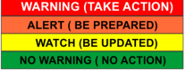
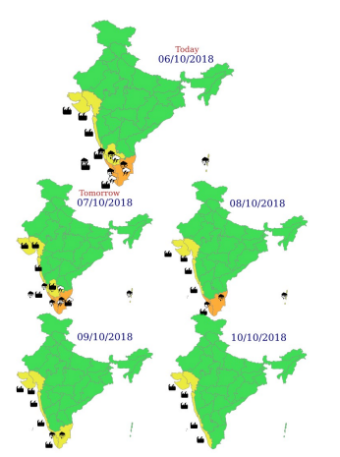

- Flood Situation on 6th October 2018

Extreme Flood Situation - Water Level above Highest Flood Level (HFL)
Severe Flood Situation - Water Level between HFL & Danger Level (DL)
Above Normal Flood Situation - Water Level between DL & Warning Level (WL)
Normal Situation - Water Level Below Warning Level
Inflow above Threshold Limit for Reservoir
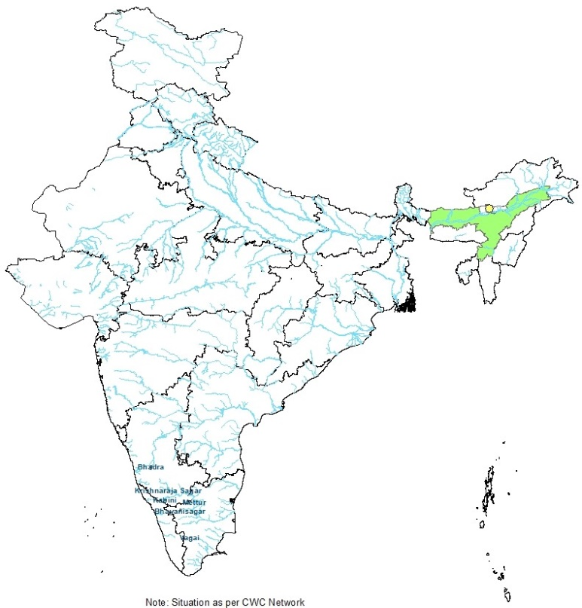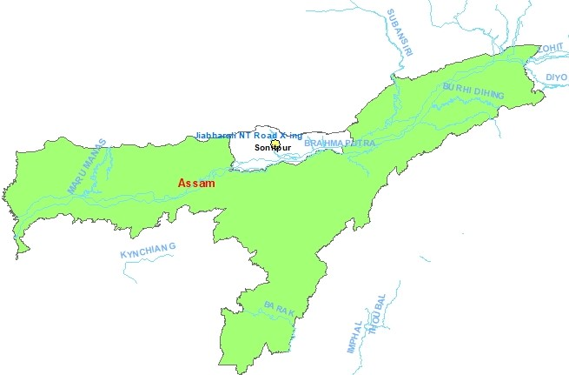

  - Summary of Flood Situation as per CWC Flood Forecasting network

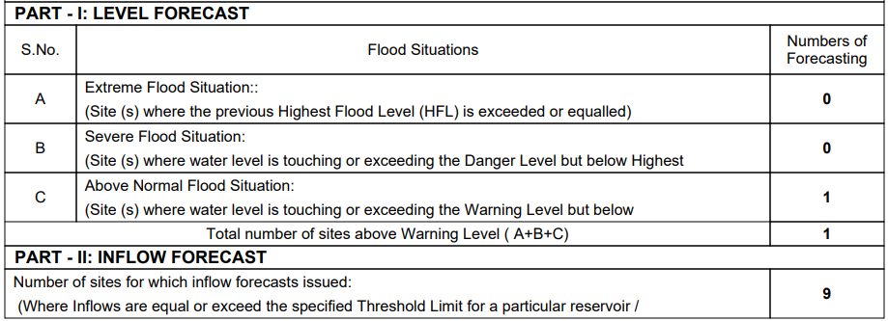

    - Above Normal Flood Situation

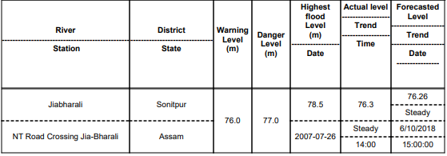

    - Reservoir

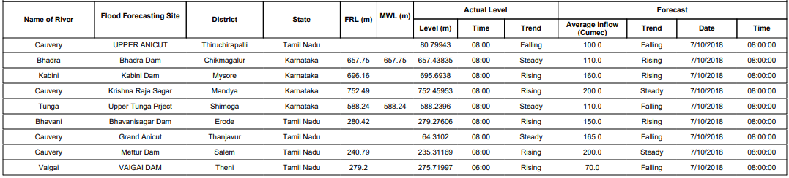

  - Flood Situation & Advisories as per Actual/ Forecasted Rainfall

2.2.1 Kerala, Karnataka and Tamilnadu
There is forecast of isolated heavy to very heavy rainfall in Kerala and Tamilnadu on 7th, 8th and 9th October and heavy rainfall at isolated places on 10th October in Kerala and in Coastal and South Interior Karnataka on 7th October. Since many of the dams in these regions are 75 to 95% of their full capacity, necessary precautions and proper gate operations along with warnings to downstream areas need to be taken as per Standard Operating Procedures in case of release of water from dams.

