Central Water Commission
Daily Flood Situation Report cum Advisories
20-09-2018
- Rainfall Situation

Chief Amount of rainfall recorded at 0830 hours IST of today (2 cm or more) as per IMD
Name of Place (State) | Rainfall (in cm)
Bhograj (Odisha) | 13
Kakatpur and Paradeep (Odisha) | 10 each
Nalgonda (Telangana) | 9
Alipingal (Odisha) | 8
Paramakudi (TN), Tandur and Devarakonda (Telangana), Rajghat and Bhubaneshwar (Odisha) | 6 each
Mayabander and Hut Bay (Andaman & Nicobar), Chandbali, Chandanpur, Rajkanika, Nilgiri, Jaipur and Govindapur (Odisha), Gadag (Karnataka) | 5 each
Canning (WB), Balasore (Odisha), Karaikudi (TN), Piravom (Kerala), Bijapur and Raichur (Karnataka), Srisailam and Visakhapatnam (AP), Ramayampet (Telangana) | 4 each
Shanti Niketan, Berhampore and Burdwan (WB), Portblair (Andaman & Nicobar), Puri (Odisha), Chalakudy (Kerala) Vijayapura & Sedam (Karnataka), Mandasa, Ichchapuram, Palasa, Kalingapatnam (AP), Venkatapuram, Alampur, Palem (Telangana) | 3 each
Krishna Nagar (WB), Chittorgarh (Rajasthan), Kurnool (AP) Illayangudi, Kovilankulam, Vaniyambadi, Tirumangalam (TN), Aluva, Peermade, Irinjalakuda (Kerala), Deodurg (Karnataka), Cheepurupalle, Palakonda, Tekkali, Garividi, Chintapalle, Pathapatnam, Macherla (AP), Jukkal, Nawabpet, Achampeta, agarjunsagar, Kodangal, Kosgi, Makthal (Telangana) | 2 each

1.1 Rainfall forecast for next 5 days issued on 20th September 2018 (Midday) by IMD

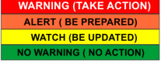
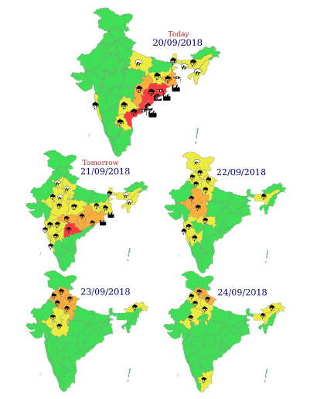
- Flood Situation on 20th September 2018

Extreme Flood Situation - Water Level above Highest Flood Level (HFL)
Severe Flood Situation - Water Level between HFL & Danger Level (DL)
Above Normal Flood Situation - Water Level between DL & Warning Level (WL)
Normal Situation - Water Level Below Warning Level
Inflow above Threshold Limit for Reservoir
2.1 Summary of Flood Situation as per CWC Flood Forecasting network
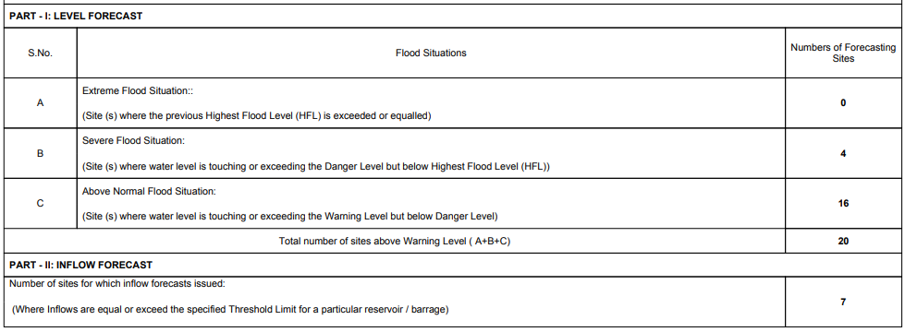
    - Severe Flood Situation

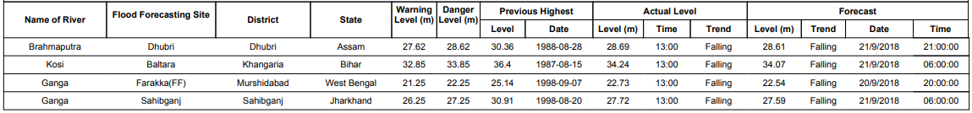
    - Above Normal

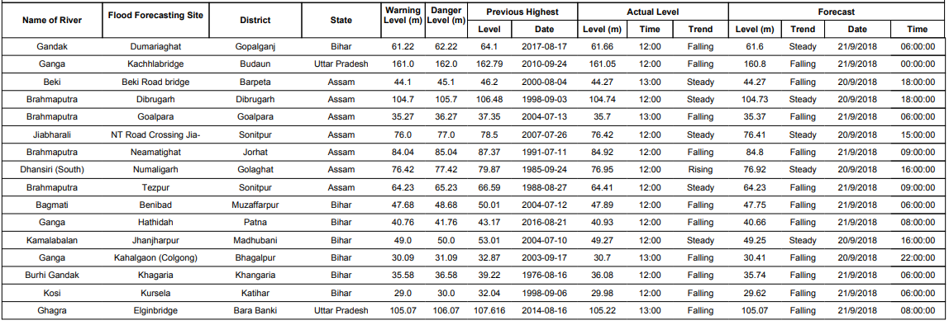
2.1.3 Reservoir
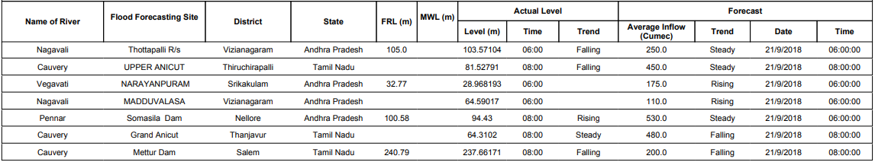
  - Flood Situation & Advisories as per Actual/ Forecasted Rainfall

2.2.1 Odisha, North Andhra Pradesh and Chhattisgarh
Due Deep Depression and its likely intensification into Cyclonic Storm, its movement towards South Odisha, North Andhra Coast and crossing between Kalingapatnam (Andhra Pradesh) and Puri (Odisha) during 20th September midnight and 21st September Early Morning, heavy to very heavy rainfall at few places with isolated extremely heavy rainfall has been forecasted for Odisha and North Coastal Andhra Pradesh on 21st and over Telangana on 22nd September along with heavy to very heavy rainfall in Chhattisgarh, Odisha and Vidarbha on 22nd September. This may lead to rise in levels in rivers Mahanadi Rishikulya, Vamshadhara & Nagavali basins as well as Pranhita, Indravathi and Sabari sub-basins of Godavari Basin. Inflows in to the reservoirs in these basins are also likely to rise. Since most of the major reservoirs are filled up between 86 to 96% of their capacity in Odisha, the releases from dams if any have to be taken very carefully taking into consideration downstream flood situation and the likely rough to very rough sea conditions.
In Nagavali Basin, Thottapally Reservoir (Vizianagaram Dist., Andhra Pradesh) is getting about 5,000 cusec of inflow and is releasing the same. Narayanapuram Anicut is getting about 4,000 cusec inflow and is releasing the same amount and Madduvalasa Reservoir is getting about 2500 cusec inflow and is being released. These reservoirs are likely to get increased inflows which may give rise to flooding in Srikakulam Town on river Nagavali. Necessary precautionary measures have to be taken on priority basis in these areas.
2.2.1.1 Districts Alerted:
Puri, Gajapati, Rayagada, Nowrangpur, Malkangiri, Koraput (Odisha), Srikakulam, Vizianagarm and Visakhapatnam (Andhra Pradesh), Dhamtari, Bastar, Sukma, Narayanpur, Bijapur, (Chhatisgarh)

