Central Water Commission
Daily Flood Situation Report cum Advisories
05-10-2018
- Rainfall Situation

Chief Amount of rainfall recorded at 0830 hours IST of today (4cm or more) as per IMD
Name of Place (State) | Rainfall (in cm)
Ennore (TN) | 13
Chengalpattu (TN) | 12
Kurudamannil (Kerala) | 11
Cholavaram (TN) | 9
Marakkanam, Vanur & Ponneri (TN), Konni, Kozha & Taliparamba (Kerala), Bantwal (Karnataka) | 8 each
Palani, Tindivanam, Nagercoil, Palayamkottai, Madavaram & Anaikaranchatram (TN), Kozhikode & Punalur (Kerala), Mudubidre (Karnataka) | 7 each
Chengam, Radhapuram, Kelambakkam, Maduranthagam, Jayamkondam , Sathanur Dam , Gingee, Red hills, Puzhal, Chennai Airport, Uthangarai & Poonamalle (TN), Mani (Karnataka), Tada & Satyavedu (Andra Pradesh) | 6 each
Uthiramerur, Pechiparai, Chennai, Tiruvannamalai, Thiruthuraipoondi, Kancheepuram, Karaikal Sriperumbudur, Mahabalipuram, Arani , Kodavasal, Shencottah, Tiruvarur & Chembarabakkam (TN), Aluva, Piravom & Munnar (Kerala), Karkala (Karnataka), Sullurpeta (Andra Pradesh) | 5 each
Taramani, Thamaraipakkam, Mylam, Vilupuram, Nagapattinam, Poonamallee, Sirkali Virudachalam, ChiDambaram, Coonoor, Tiruvallur, Tambaram, Vandavasi, Annauty, Cuddalore, Panruti, Melalathur, Parangipettai, Anna University, Sethiathope , Tarangambadi, Needamangalam, Ulundurpet & Pochampalli (TN), Kottayam & Vythiri (Kerala) Mangaluru & Mulki (Karnataka), Gurramkonda, Rapur (Andhra Pradesh) | 4 each

1.1 Rainfall forecast for next 5 days issued on 5th October2018 (Midday) by IMD

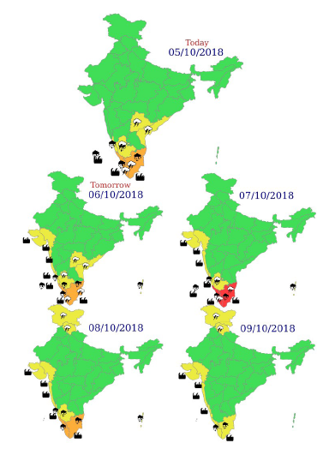

- Flood Situation on 5th October 2018

Extreme Flood Situation - Water Level above Highest Flood Level (HFL)
Severe Flood Situation - Water Level between HFL & Danger Level (DL)
Above Normal Flood Situation - Water Level between DL & Warning Level (WL)
Normal Situation - Water Level Below Warning Level
Inflow above Threshold Limit for Reservoir

  - Summary of Flood Situation as per CWC Flood Forecasting network

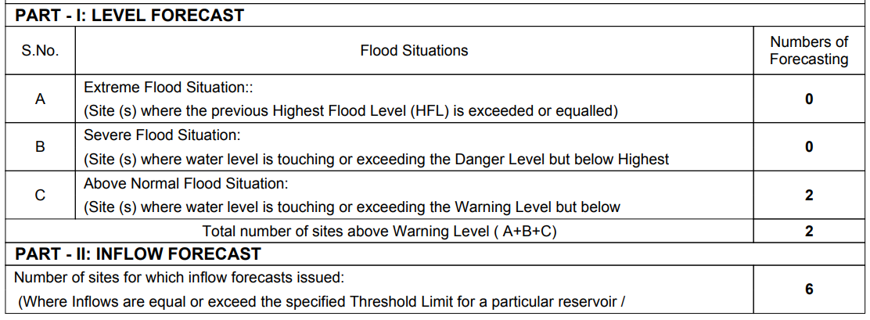
Danger level
Flood level

    - Above Normal Flood Situation

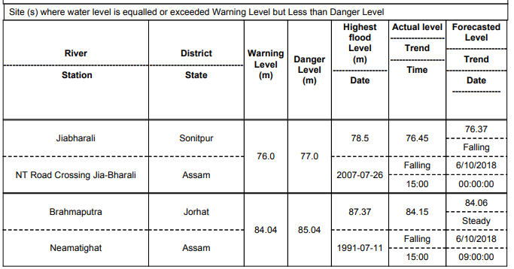

    - Reservoir

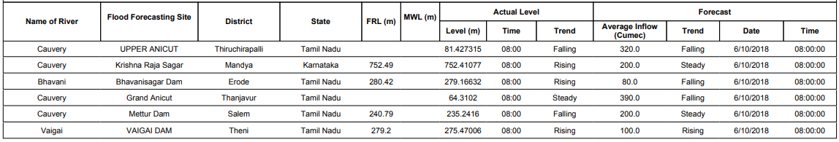

  - Flood Situation & Advisories as per Actual/ Forecasted Rainfall

2.2.1 Kerala, Puducherry and Tamilnadu
Districts for which heavy to very heavy rainfall warning has been issued by IMD for 6th October 2018 is given in Map below

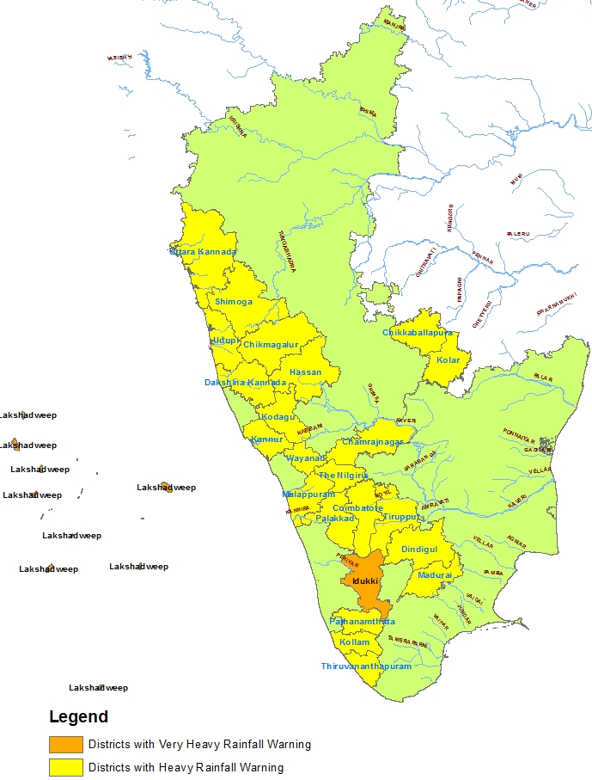

The map indicates that very heavy rainfall is likely over Periyar basin in Kerala, and Heavy rainfall is likely in the basins of Bharathapuzha, Pamba & Achenkovil in Kerala and in Bhavani, Amaravathi, Moyar, Noyyal & Vaigai Basins in Tamilnadu which are alerted for rise in water levels. Further heavy to very heavy rain is likely to occur at isolated places over Tamilnadu & Puducherry and Kerala valid upto 7th from 6th October and 9th October from 8th October. Heavy to very heavy rain with extremely heavy falls likely at isolated places over Tamil Nadu and Kerala has been forecasted valid upto 8th October from 7th October. Heavy rainfall is also forecasted at isolated places in Tamilnadu and Kerala valid upto 10th October from 9th October. Since many of the dams in these regions are 75 to 95% of their full capacity, necessary precautions and proper gate operations along with warnings to downstream areas need to be taken as per Standard Operating Procedures in case of release of water from dams.

